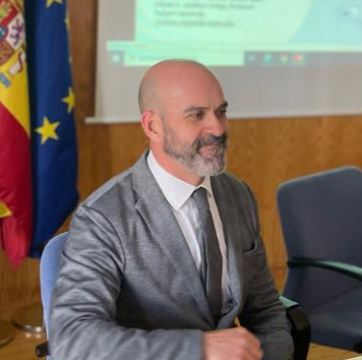
Keynote Speaker
Miguel A. Jimenez-Crespo is a Professor in the Department of Spanish and Portuguese at Rutgers University, where he directs the MA program in Spanish Translation and Interpreting. He holds a PhD in Translation and Interpreting Studies from the University of Granada, Spain. His research focuses on the intersection of translation theory, translation technology, digital technologies and artificial intelligence, corpus-based translation studies and translation training.
TOPIC: Translation as a Profession in the Age of AI: Redefining the Human-Machine Tandem - Over the years, the translation profession has been evolving to include the impact of technological innovation. Today, advances in Artificial Intelligence (AI) and generative Large Language Models (LLMs) are starting to revolutionize how we perceive and engage with technologies during translation tasks (O’Brien 2023; Jiménez-Crespo 2024), and by extension, in translation training programs. This presentation discusses how research on human-centric AI and intelligence augmentation can help us re-conceptualize the role of professionals in translation, taking into account their agency, autonomy and unique skills. It will be argued that this approach can provide an empowering and clear vision for the translation profession in the near future.
Objectives
1. Understand the role of expert translators in their interaction with AI and translation technologies
2. Understand the limitations of AI tools such as generative large language models, as well as how they can/could be incorporated to translation tasks
____________
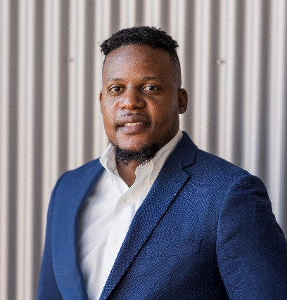
Steeve Auguste, CEO of Precise Translation International and Haitian Creole Interpreter/Translator, was born and raised in Carrefour, a city in Port-au-Prince, Haiti. He moved to the United States in 2016 after completing his college in Haiti. Steeve started to work in Haiti as an interpreter after the big earthquake that devastated Haiti in 2010. He worked with Non-governmental agencies, Medical missionaries, Hospital and University as a professional translator. In 2019t, he completed an interpreter certificate training and started to work in the Boston area community. He started working with Interpreting Agencies, then joined Boston Children’s Hospital where he worked as a medical interpreter for about 2 years. He joined the Everett Public Schools family in 2020, where he served as a Haitian Creole family liaison facilitating communication and teaching experience for the limited English proficient speaking families in the Haitian community living in the Everett community area and increase parent involvement in their children’s education. With over 10 years in the field of translation and interpretation, with the influx of the immigrants in the US this past year, Steeve has decided to start his own company (PTI -Precise Translation International) to provide translation and interpretation services mostly in the Northeast region.
TOPIC: Artificial Intelligence in the Translation Services Industry
Artificial intelligence is rapidly changing the world as we know it. One area where artificial intelligence is becoming increasingly important is the translation services industry. Translation tools and software are now more refined than ever before, making it easier for individuals and businesses to communicate effectively.
The AI software market is going from strength to strength.
Language translation looks set to remain a key part of AI software and shape the future of the industry. However, can an artificial language translate as well as humans? Currently, even the best language translation tools can’t perform autonomously. However, AI in translation industry as a whole is quickly reshaping, carving out new niches for human translators, and changing the way machine translation technology is used in everyday life. Coming with solutions with the risks of AI- Raising awareness of AI in the industry - Using AI to ease our job.
____________
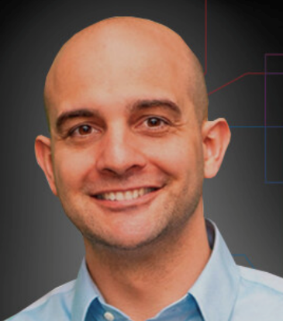
Federally certified court interpreter Javier Castillo has provided certified forensic transcription/translation of thousands of audio/video files for federal and state cases. He has not only received specialized training in forensic transcription/translation but has designed courses on the subject and been a presenter at State and National Conferences. Mr. Castillo has been qualified as and has testified as an expert witness in State and U.S. District Courts on Forensic Transcription and Translation

TOPIC: Intro to Forensic Transcription and Translation
As court interpreters and translators, we are often asked to provide transcripts of foreign language audio and video, from recorded interviews to undercover operations. In this interactive session you will learn what you need to get started in the world of forensic transcription and translation. We will cover: Preparation, Equipment needs, Software, Protocol and Best Practices.
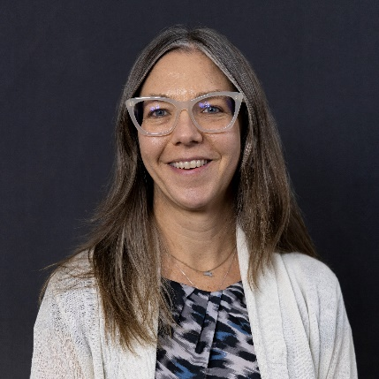
____________
Elena Langdon Interpreter, translator, and interpreter trainer

TOPIC: “He Is Not my Husband” – Advocacy in Healthcare and Community Interpreting
Advocacy is part of the role of professional healthcare interpreters in the US, yet it remains misunderstood, ill-practiced, and/or feared by many. Additionally, in many other public service (or community) settings, standards of practice are either non-existent or newly established. In this session we will explore the guidelines and the code of ethics to fully understand the underpinning of advocacy in public service (or community) interpreting. We will discuss specific scenarios and examine decision-making steps. We will also talk about the actions an interpreter should take when deciding to advocate during or after an encounter. Examples and discussion will refer to both in-person and remote interpreting.
Learning Objectives:
1. By the end of the session, participants will be able to articulate the role of advocacy in professional healthcare interpreting in the United States, including its importance, challenges, and common misconceptions.
2. Participants will gain a comprehensive understanding of the guidelines and code of ethics governing advocacy in public service or community interpreting, enabling them to apply ethical principles to their decision-making processes during interpreting encounters. 3. Upon completion of the session, participants will develop practical skills in identifying situations where advocacy may be warranted during or after an interpreting encounter and will be equipped with decision-making frameworks to effectively navigate such scenarios, whether in-person or through remote interpreting platforms.

____________
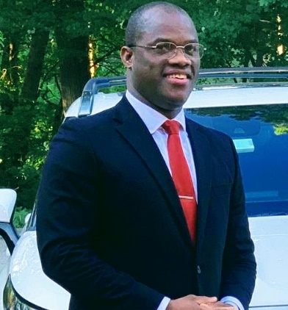
Convington Bien-Aimé, Massachusetts Trial Court Staff Haitian (and French) Interpreter, earned his bachelor’s degree in Small & Medium-Sized Enterprises in Haiti at Quisqueya University, and his MBA at UMass-Lowell. While majoring at Quisqueya he worked for the United Nations (under MINUSTHA) for 6 plus years as Human Resources Professional. Now Mr. Bien-Aimé has been working at the Office of Language Access, OLA / Massachusetts Trial Court for six plus years where he has started as a Project Coordinator contractor in November 2017.
Screened by OLA, Mr. Bien-Aimé became French and Haitian Per Diem Interpreter-Translator in August 2018. His level of commitment, work ethics and professionalism in performing his job has catapulted him to the Court Interpreter Scheduler position in January 2022. In January 2023, the Court Administrator has appointed him to the Haitian Interpreter position.
JEBCA Editions has published Mr. Bien-Aimé’s first book Bidimensional Thought on Dance in December 2022, and as a Notary Public the author is also serving the Commonwealth of Massachusetts since October 2023.
TOPIC: Rendition of Interpreters and the Level of Understanding of LEP Individuals: Infrequent Mistrust from the Various Types of Stakeholders
Someone must be as bold as grass to come to NETA with such a subject RENDITION OF INTERPRETERS AND THE LEVEL OF UNDERSTANDING OF LEP INDIVIDUALS: infrequent mistrust from the various types of stakeholders. This title has come into existence due to ups and downs I have experienced in courts for the five plus years. Those experiences consist of 1) discussing the application and interpretation of some rare words, say, non-binding bench trial, plea…, with other colleagues; 2) communications I’ve had with stakeholders, such as judges, attorneys, to name a few. 3) the role of interpreters and the other stakeholders to ensure that LEP individuals obtain equal access to justice.
I have realized that those discussions and communications were going to be a springboard for me to bring to your attention various obstacles I have met during my continuous ongoing rendition expedition. In closing, I have found some antidotes to the obstacles, which you will enjoy at the end of this presentation.
Goals:
- This article will be a point of discussion where we will analyze together ups and downs, we have experienced while performing our job of interpretation. So, this forum intends to change, if not enhance, the mindset of those who are functioning as interpreters to cultivate remarkable equanimity when things do not look well either in the courtroom or outside the courthouse.
- Be more professional in upholding standards of practice to preserve integrity.
- Encourage interpreters to pay close attention to their behavior and actions. Verbal and non-verbal displays of personal attitudes, prejudices, emotions, or opinions must be always avoided accordingly.
Objectives:
- Be mindful of your rendition (for it to be as accurate as possible) to the LEP Individual.
- Mitigate the identified hindrances with respect to the perception of judges, clerks, attorneys versus interpreters, and vice versa.
- Consider the role of the interpreter as a key component in assessing their ability to professionally fulfill assignments.

____________
Özüm Arzık-Erzurumlu is a visiting scholar at the University of Massachusetts, Amherst. Her research interests cover interpreting, sociology of interpreting, interpreter training and interpreting history. She is a professional conference interpreter and a member of the Turkish Conference Interpreters’ Association. She teaches consecutive and simultaneous interpreting with a focus on the use of technology in interpreting. Her research appeared in journals including Translation and Interpreting Studies and Interpreting. She has interpreted the American Presidents for Turkish televisions since 2007.
TOPIC: Interpreting as Emotional labor: Exploring the Social Carpet of Conference Interpreting
Arzık-Erzurumlu will discuss the intricate dynamics between interpreters and their subjects, drawing from her experiences interpreting former American Presidents like Donald Trump and Joe Biden. Through both academic research and personal anecdotes, she will illustrate how interpreters often form attachments to the individuals they interpret. Furthermore, she will delve into the challenges faced by interpreters when dealing with traumatic events, such as the Ukrainian-Russian war, and explore the available resources to support them in such emotionally taxing situations. The speech aims to shed light on the delicate balance interpreters must maintain between maintaining neutrality and managing their own emotions, a phenomenon often referred to as emotional labor. Arzık-Erzurumlu will delve into how this emphasis on neutrality can sometimes overshadow the human element of the interpreter's role. She will argue for a more transparent recognition of the emotional labor involved in conference interpreting and advocate for greater acknowledgment of interpreters' agency, in highlighting the ways in which interpreters engage with the speakers and the texts they interpret for; underscoring the fact that neutrality in interpreting is a myth; discussing the coping mechanisms interpreters may employ in emotionally taxing situations their work.
____________
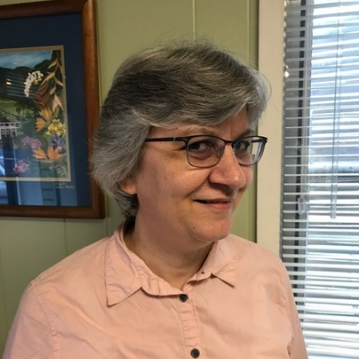
Helen Eby is an active ATA-certified Spanish translator and a certified court and healthcare interpreter. Besides providing services personally, she provides training for Spanish interpreters and translators who want to be certified.
Helen follows ASTM guidelines for interpreting and translation and promotes them to her clients. She has also been involved in policy discussions with government officials who seek to promote better language access.
Helen believes in the power of professional associations to promote best practices and advocate for the profession. Because of that, she has been involved in leadership in national and local associations. She has been a NETA member off and on since the late ‘90s.
TOPIC: Translating and interpreting: How do they differ?
What is the difference between translators and interpreters? The differences are based on the type of work we do, the place where we do it, the resources we have available, the possibilities for research and editing... and the purpose of the work we do.
Interpreters and translators from Europe, South America and the US teamed up to consider this issue and write job descriptions that would help HR people find the right people for this work. Since then, these documents have been used by HR staff to provide better language access services.
Helen Eby was the team lead on this project and will share the conclusions of the team's work. Participants will be invited to see how we reached these conclusions and think of how they can grow in the profession.
By having a clear understanding of the work we do, we can support our profession more strongly.
Objectives
- Define translation and interpreting.
- Consider the environments in which translators and interpreters work.
- Review the commonalities between translation and interpreting.
- Review the differences in resources available to translators and interpreters.
- Review the technology tools available to translators and interpreters.
- Consider how we need to grow as professionals in our field.

____________
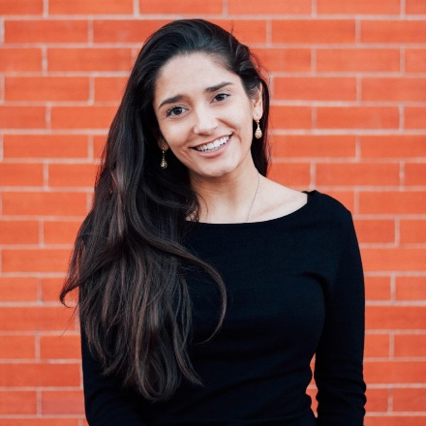
Regina Zaragoza Frey DEI Director, City of Salem, and Alexandra Fortich Salem Public Schools Translations and Interpreters Coordinator
Regina Zaragoza Frey hails from Querétaro, México, and currently serves as the inaugural Diversity, Equity, and Inclusion Director for the City of Salem. Her role was established to elevate issues of race and equity within the City's operations, influencing all departments through a variety of initiatives. Her role extends beyond internal operations as she seeks to bridge the City and community, particularly focusing on the needs of historically underrepresented and systematically excluded individuals. Regina is multilingual and her academic qualifications include a Master of Law in Ethics and Compliance, as well as two Bachelor’s degrees, all from the University of Colorado.
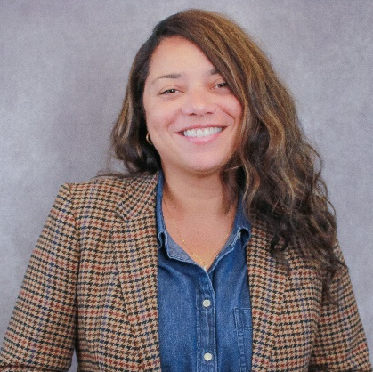
Alexandra Fortich, originally from Colombia, spent 24 years immersed in its vibrant culture before venturing into the field of communication. With a degree in Communication from Universidad Santo Tomas in Bogotá, she has spent seven years in language services, specializing in medical and community interpreting. Currently, as manager of language access services in Salem Public Schools, she ensures equitable language support for all. Her expertise extends to other districts, including Holyoke, Worcester, and Amherst, enriching educational environments with her language skills and commitment to inclusion. Alexandra is dedicated to bridging cultural differences through effective communication and fostering diverse and thriving communities.
TOPIC: Language Access: Public Schools Leading the Way for Municipalities
The City of Salem exemplifies how public school systems can lead municipalities in enhancing language access practices. At the forefront of this initiative, the city's schools utilized ARPA funding to bolster language accessibility. This involved the creation of a Language Coordinator role, the implementation of a stipend program for bilingual employees, and the requirement for all public-facing documents to be available in multiple languages. These measures have not only benefited students and their families but also set a benchmark for other municipalities aiming to improve language access. This presentation explores the proactive approach taken by public schools in Salem, emphasizing their role in overcoming language barriers to ensure equitable access to essential services and information. It highlights the collaborative model adopted by these institutions, serving as a blueprint for other cities to foster linguistic diversity and equity in public service.
Objectives:
- Start with context: why does Language Access matter in the City of Salem and... everywhere?
- Difference between language access and language justice
- Overview of the Language Access Policies in the Salem Public School and the City of Salem
- Challenges to implementing Language Access policies in SPS and the City

____________
Barbara Thimm, Literary Translator, writer, educator, received an MFA from Columbia University. Her translations of selected poems by Timothy Donnelly and Mary Jo Bang were published by luxbooks in Germany. A Discovery Behind the House, the English translation of a short story by Ror Wolf, appeared in Asymptote in 2018. She is currently working on the translation of Ror Wolf's first novel.
TOPIC: Writing Through Translation: Applying Writing Process to Translating Literature
It is a well-known fact that the translator, as both a reader and a writer, plays a dual role in interpreting and recreating texts in a new linguistic and cultural context. However, the exploration of the translator's role as a writer, particularly in how writing techniques and tools influence the translation process, remains relatively uncharted territory.
This talk examines the interplay between literary translation and writing, showing how insights from writing research can be helpful for our practice and understanding of literary translation. It highlights the translator's complex role as researcher, reader, and writer, emphasizing how to use research findings on the cognitive processes of writers in the practice of literary translation. Examples from my translation and teaching practice will illustrate these connections.
This talk aims to inspire translators and teachers alike, showing that understanding translation as a writing process is both useful and inspiring.
After the session participants will be able to:
- distinguish the bases of the writing process and their cognitive demands;
- apply their understanding to the translation process;
- reflect on their own approach to literary translation;
- (create meaningful assignments for their teaching practice).

____________
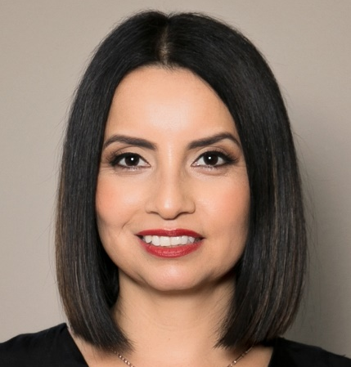
Mireya Pérez - Language Services Coordinator, interpreter in education, podcast host, devoted to language access, honed her abilities as a certified medical interpreter in general and children's hospitals. With nearly a decade as a staffed interpreter in a K-12 public education school district, she played a vital role in creating language access policies and procedures throughout the district.
Armed with a Master's in Communications, Mireya is the creator and host of the Brand the Interpreter podcast. This platform serves as a conduit for the stories and perspectives of language professionals worldwide, reflecting her commitment to amplifying their voices. In addition to her podcast, Mireya passionately advocates for language access policies in public education.
TOPIC: Interpret your Identity: Unleashing the Power of Personal Branding for Language Professionals
Unlock your potential in Interpret Your Identity: Unleashing the Power of Personal Branding for Language Professionals. This one-hour workshop guides interpreters and translators in crafting a distinctive voice, understanding brand positioning, and shaping compelling narratives. Engage in hands-on activities to hone online presence and visualize your brand. The interactive session introduces personal brand power in a reflective and engaging environment. Join us to cultivate a resonant brand, connecting and propelling your career in the diverse realm of language services. Gain practical skills, have fun, and elevate your impact. Whether you're an interpreter or translator, this workshop provides tools for visibility and lasting influence.
Objectives: Through this workshop, participants will gain a deeper understanding of:
1. Personal brand elements - Identify key personality traits, values, and strengths that define individual professional identities
2. Visualize brand identity - Understand the importance of brand positioning.
Engage in hands-on activities to visualize and create a visual representation of their personal brand.
3. Craft compelling narratives - Develop a professional commercial that communicates journey, expertise, and passion for language services.
4. Optimizing online presence - Explore strategies for enhancing online presence, including social media and professional networking.
____________
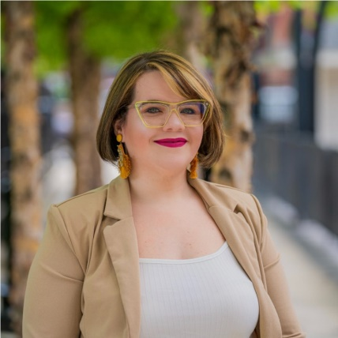
Jasarah Burgos - Chief of Community Engagement for New North Citizens Council & Founder of the Family & Community Engagement Network of Western MA, Chief of Community Engagement As the current Chief of Community Engagement for New North Citizens Council in Springfield, MA, she brings a wealth of experience and dedication to fostering community relations. An expert in Family and Community Engagement, she is known for their innovative approach to professional development, especially in building the capacities of Family Engagement professionals across western Massachusetts.
Jasarah's work transcends traditional roles, blending expertise with a deep commitment to community activism. Driven by the belief in collective effort, she is at the forefront of initiatives aimed at improving the community. This dedication is fueled by a vision to leave a lasting legacy for future generations and to instigate meaningful, impactful changes within organizations.
With a career marked by advocacy, leadership, and a passion for community betterment, Jasarah continues to be a pivotal figure in shaping a more engaged, informed, and cohesive community in Springfield and beyond.

TOPIC: Bridging Language Barriers: Enhancing Family and Community Engagement Through Language Access
Language barriers pose significant challenges in fostering meaningful family and community engagement. In our workshop, 'Bridging Language Barriers: Enhancing Family and Community Engagement Through Language Access,' participants will delve into the importance of language access and explore practical strategies to overcome linguistic challenges. Through interactive discussions, skill-building exercises, and real-life case studies, attendees will gain insights into effective communication techniques, including the use of interpretation services and culturally sensitive approaches. Expert insights from professionals in language access and community engagement will enrich the discussion. By the end of the workshop, participants will leave equipped with actionable plans to implement language access initiatives in their organizations or communities, ensuring inclusivity and strengthening connections with linguistically diverse families and communities. Join us in empowering effective communication and fostering inclusive engagement across language barriers.
Objectives:
- Increase Understanding of Language Access Importance
- Enhance Communication Skills for Linguistically Diverse Settings
- Empower Action and Implementation of Language Access Initiatives
____________
Endnote Speaker
Ross Perlin is the author of Language City: The Fight to Preserve Endangered Mother Tongues and co-director of the Endangered Language Alliance
TOPIC: Language City: The Fight to Preserve Endangered Mother Tongues
Contemporary cities are the most linguistically diverse in history, even as an estimated half of the world’s 7000-plus languages are endangered. How did this happen, and what does it mean for the future of language? Home to over seven hundred languages, early 21st century New York City is a paradigm case, but many other cities are likewise becoming improbable refuges for Indigenous, endangered, and primarily oral languages. Neither the languages themselves, nor the knowledge they contain, nor the new urban linguistic diversity of which they are a part, have been adequately documented. Yet the settling of many speakers in cities with communities of linguists, language activists, translators, and language enthusiasts presents an opportunity. Issues of language access and language justice are more pressing than ever before, with governments, businesses, schools, and other institutions scrambling to build a linguistic infrastructure that can match a linguistic diversity paradoxically both growing and threatened.

THANK YOU TO OUR SPONSORS
